Induction Motor Speed Controller Project

Induction motors have been used widely in different fields ranging from domestic appliances to industrial machinery. This necessitates a speed control mechanism that is efficient and is also safe to use. Induction Motor Speed Control Project serves this purpose of controlling the speed of the induction motor. Induction motor runs through direct AC line the amount of power given to it decides to what RPM it does rotates. We can modulate the power of the AC line to vary the speed of the induction motor through AC driver circuitry. An Atmega family microcontroller is used to give PWM power to an opto-coupler which drives the TRIAC giving supply to the induction motor. In this way, with the help of two push buttons one can control the speed of the induction motor electronically and also very efficiently. This whole process is also displayed on an LCD which acts as user interface and thus helping the user getting informed about it. In this way this project is quite useful in controlling an Induction Motor and having good efficiency while doing so.

Block Diagram :
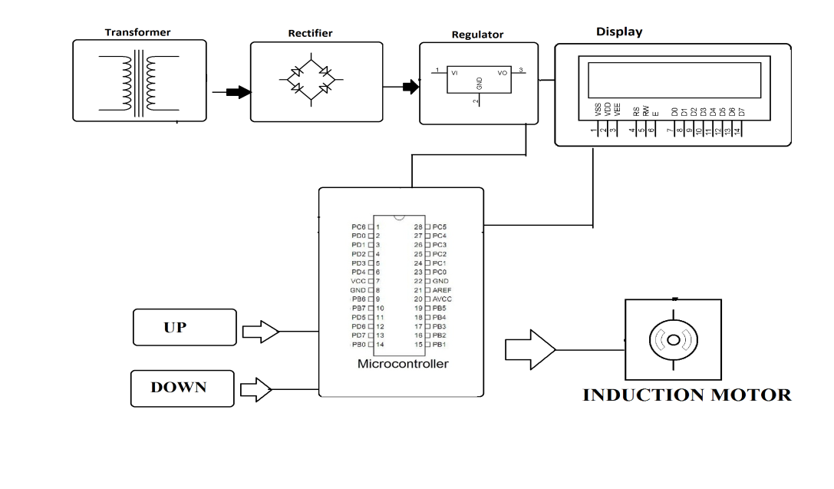

Hardware Specifications
- Transformer
- Rectifier
- Regulator
- LCD Display
- Atmega 328 Microcontroller
- Induction Motor
- Resistors
- Capacitors
- Diodes

Software Specifications
- Arduino Compiler
- Programming Language: C

